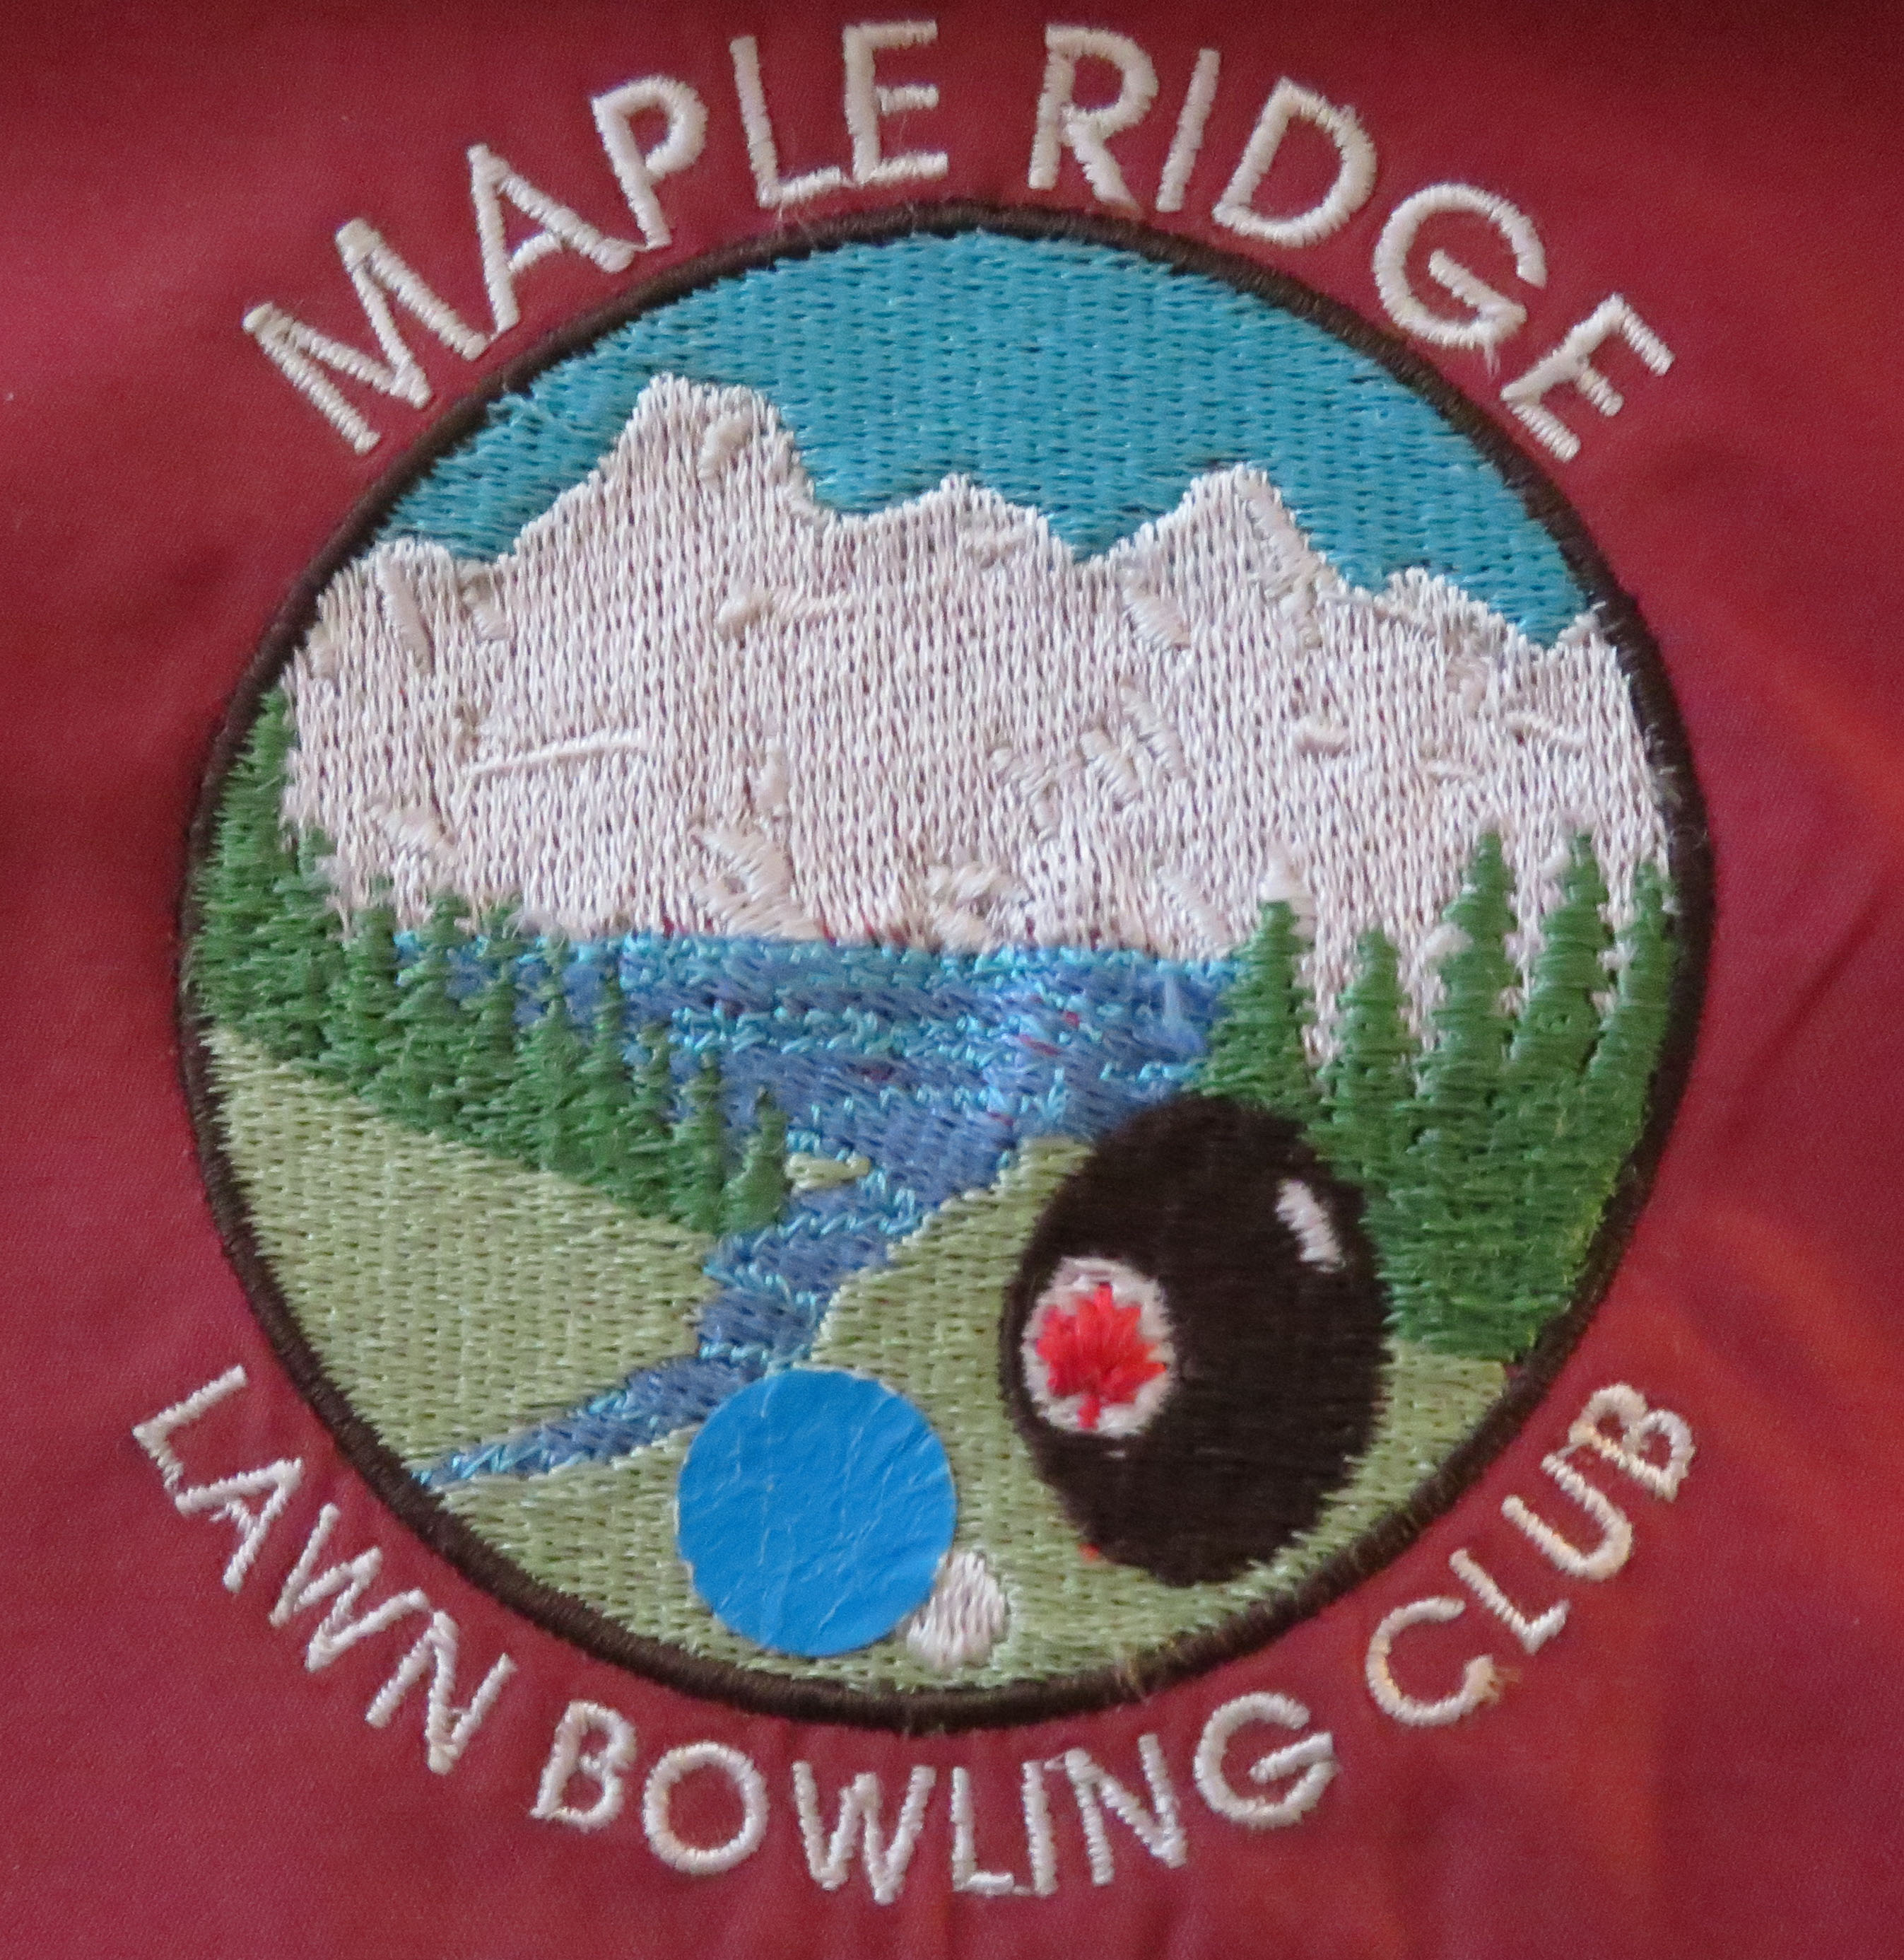
MAPLE RIDGE LAWN BOWLING CLUB ASSOCIATION
11445 – 232ND Street, Maple Ridge, BC V2X-3R3
APPLICATION FOR MEMBERSHIP

Please complete a separate form for each household member. Returning members complete only if info has changed.
Name: (in full) ______________________________________________________________________________
Address: __________________________________________________________________________________
City: _______________________________________________________ Postal Code ____________________
Telephone: _______________________ Email Address: ____________________________________________

Are you able to receive emails (please circle) YES NO / Are you able to print emails (please circle) YES NO

Age Category – Age range is a requirement of Bowls BC and Bowls Canada (please circle)
6-12 13-17 18-54 55+

Emergency Contact: ________________________________________________
Relationship: ________________________________________ Phone: ______________________

I AM WILLING TO SERVE AS A CLUB VOLUNTEER in the following area(s). Please circle at least one:

Kitchen/Social Games Buildings Coaching Executive Greens & Grounds Tournament Convener

The following request for your consent is a requirement of the Personal Information Protection Act of British Columbia. (Please Circle YES or NO). I CONSENT TO:

The publication of my name and telephone number in MRLBC Membership Directory. YES NO
The publication of my email address in MRLBC Membership Directory……………………… YES NO
The use of my email address by the President or Executive Committee for
MRLBC group and Bowls BC information updates and notices…………………………………… YES NO
The publication of your name and photograph on the MRLBC website……………………… YES NO

____________________________________ _______________________
Signature Date
MRLBC MEMBERSHIP FEE SCHEDULE (Please circle the category that applies to you)
Full Member………………………………………………………………………………………………………………………. $160.00
New to Lawn Bowling Member (includes lesson package fee $25.00) ………………………………. $135.00
New Members Only: Joining after 31st July of the current year…………………………………………. $80.00
Social Member (May join in all club activities other than Lawn Bowling) ………….………………… $25.00
Other Clubs: If you belong to more than one club, please designate your HOME club:
________________________________________________________________

